Introduction

This assignment for creation of an exercise booking system in java is meant to examine how well I understand the principles of software development in Java language. The IDE I used is IntelliJ IDEA.

The software system is to have the following functionalities:

1. Ability to book an exercise class
2. Ability to change a booking that has been previously done
3. Recording the attendance of the students in each exercise class
4. Get the review and rating from the student that attended a class
5. Share a report on the performance of the classes for the stakeholders

Assumptions

During the course of developing this project, the following assumptions were made:

* There would be no authentication needed for the students
* The student’s record exists in the system
* The demo would be for a weekend of classes
* The rating and review would be compulsory after every class
* The demo would be by hardcoded to one of the students in the system

Design and Implementation

Below are the UML diagrams and description of the main functions in the program.

1. The day and time selections are set to be enum classes for the purpose of this project

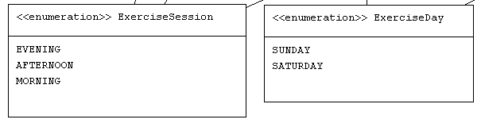

1. The Student class contains three member fields that are all private and can be accessed through the getter and setter methods. It is used in creating all student instances in the program

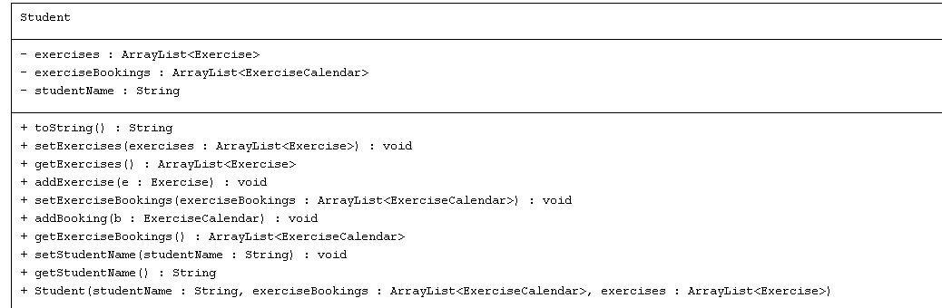

1. The Exercise class contains 5 member fields with one of the fields being a static variable. This mostly contain the setters and getters as well.

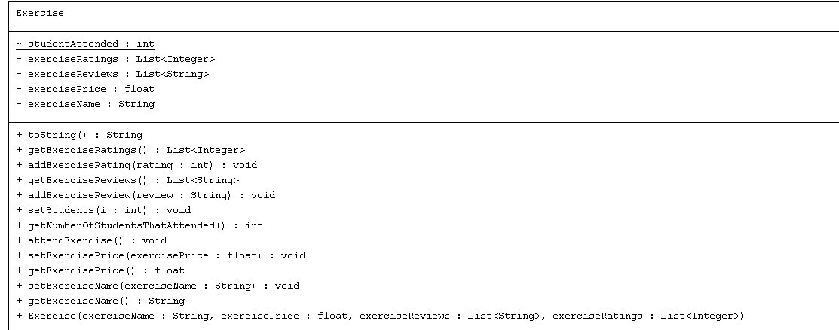

1. The Booking class is the collosal class in this program. It contains all the logic that binds the whole program together. Below is the UML diagram for this class

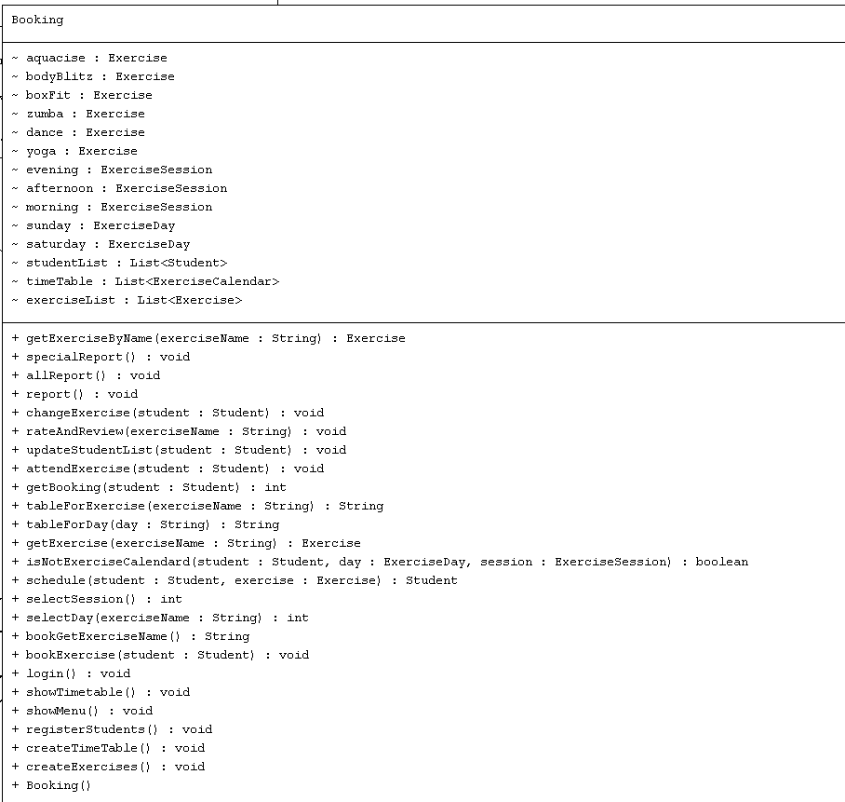

GIT COMMIT SNAPSHOT

Below is the snapshot of the git commit message for this program:

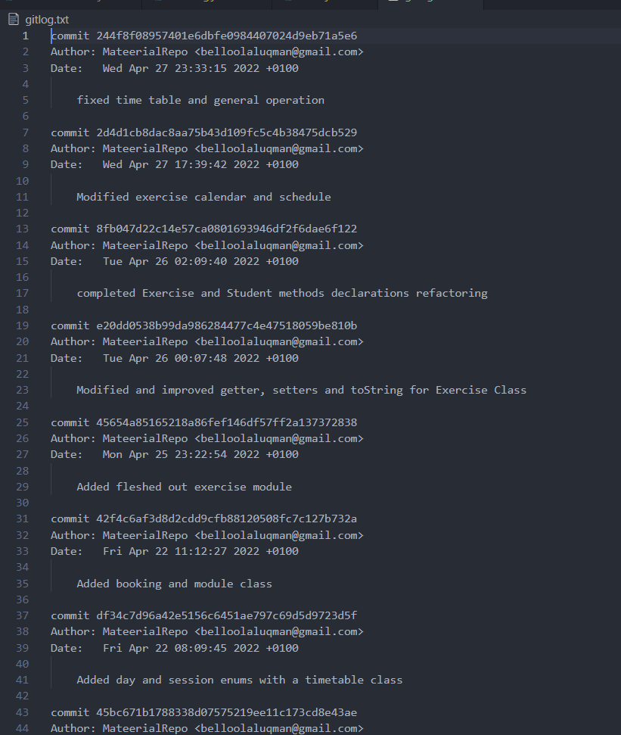

**Conclusion**

This was a very challenging project for me as I am getting to dive fulling into OOP. The whole process provided me with valuable insight on how to develop and thing through a project. I believe the project can be refactored a lot more elegantly than I have done and it has greatly improved my coding skills.

A bigger challenge was setting and doing the test, I need to improve on that significantly.

I would continue to strive and improve my programing skills in a bid to be a word class developer.

URL of Repo

http://github.com/MateerialRepo/lesson-booking-system